Pizza Sales SQL Queries
A. KPI’s
1. Total Revenue
Select sum(total_price) as Total_Revenue from pizza_sales;
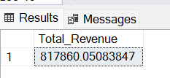
2. Average Order Value
Select sum(total_price)/count(distinct(order_id)) as Avg_Order_Value from pizza_sales;
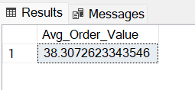
3. Total Pizas Sold
Select sum(quantity) as Total_Pizas_Sold from pizza_sales;
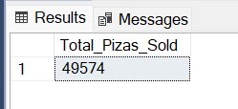
4. Total Orders Placed
Select count(distinct(order_id)) as Total_Orders_Placed from pizza_sales;
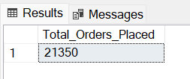

5. Avg Pizas Per Order
Select cast(cast(sum(quantity) as decimal(10,2))/cast(count(distinct order_id) as decimal(10,2)) as decimal(10,2))
as Avg_Pizas_Per_Order from pizza_sales;
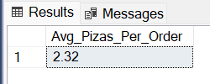
6. Daily Trend For Total Orders
Select DATENAME(dw,order_date) as Order_day,count(distinct order_id)
as Total_Orders from pizza_sales
group by DATENAME(dw,order_date);
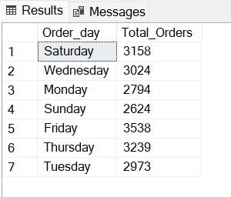
7. Hourly Trend For Total Orders
Select datepart(HOUR,order_time) as Order_Hour,count(distinct order_id)
as Total_Orders from pizza_sales
group by datepart(HOUR,order_time)
order by datepart(HOUR,order_time);
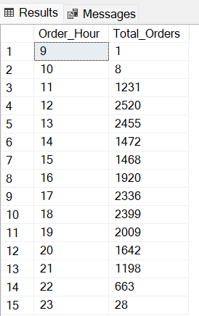
8. Percentage of Sales By Pizza Category
Select pizza_category,sum(total_price) as Total_Sales,
sum(total_price)*100/(Select sum(total_price) from pizza_Sales) as Sales_Percentage_By_Category
from pizza_sales
group by pizza_category;
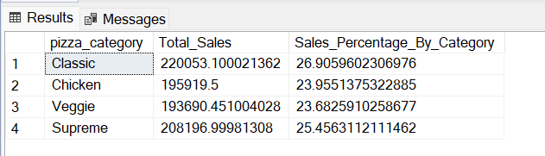
9. Percentage of Sales By Pizza Size
Select pizza_size,sum(total_price) as Total_Sales,
sum(total_price)*100/(Select sum(total_price) from pizza_Sales) as Sales_Percentage_By_Pizza_Size
from pizza_sales
group by pizza_size
order by Sales_Percentage_By_Pizza_Size desc;
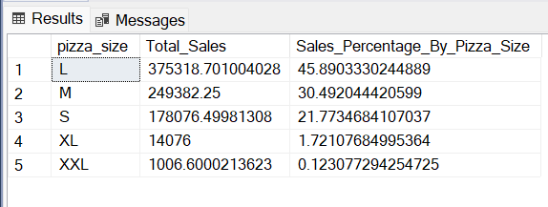
10. Total Pizas Sold By Piza Category
Select pizza_category,sum(quantity) as Pizas_Sold from pizza_sales
group by pizza_category;
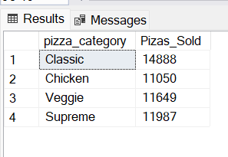
11. Top 5 Best Sellers By Total Pizas Sold
Select top 5 pizza_name,sum(quantity) as Total_Pizas_Sold from pizza_sales
group by pizza_name
order by Total_Pizas_Sold desc;
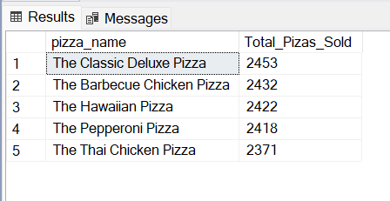
12. Bottom 5 Worst Sellers By Total Pizas Sold
Select top 5 pizza_name,sum(quantity) as Total_Pizas_Sold from pizza_sales
group by pizza_name
order by Total_Pizas_Sold;

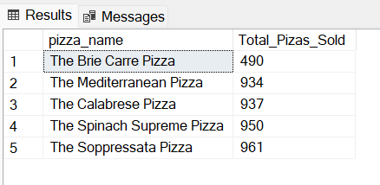
Dashboard
